H.T No
Regulations:
A17

Sreenidhi Institute of Science and Technology
(An Autonomous Institution)
Code No: 6K301 Date: 02-July-2021 (FN)

B.Tech II-Year I- Semester Pending External Examination, July - 2021 (Supplementary)
Strength of Materials-I (CIVIL)

Time: 3 Hours Max.Marks:75

Note: a) No additional answer sheets will be provided.
b) All sub-parts of a question must be answered at one place only, otherwise it will not be valued.
c) Missing data can be assumed suitably.

ANSWER ANY 5 OUT OF 8 QUESTIONS. EACH QUESTION CARRIES 15 MARKS.

Bloom's Cognitive Levels of Learning (BCLL)

Remember | L1 | Apply | L3 | Evaluate | L5
Understand | L2 | Analyze | L4 | Create | L6

 |  |  | BCLL | CO(s) | Marks
1. | a) | Draw the stress strain curve for a Mild steel bar and locate the various salient points. | L2 | CO1 | [8M]
 | b) | Determine the stress developed in the each part of the bar shown in Fig.1 and also the total change in length of the bar given E=210GPa.  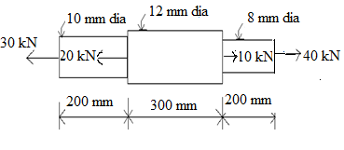 | L4 | CO1 | [7M]
2. |  | Construct S.F. and B.M. diagrams for the following loaded overhang beam as shown in Fig.2 Also locate the point of contra flexure.  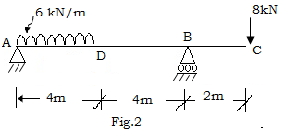 | L4 | CO2 | [15M]
3. | a) | write any FOUR assumptions in theory of simple bending. | L1 | CO3 | [8M]
 | b) | A water main of 500 mm internal diameter and 20 mm thick is running full. The water main is of cast iron and is supported at two points 10 m apart. Find the maximum stress in the metal. The cast iron and water weigh 72000 N/m³ and 10000N/m³ respectively. | L3 | CO3 | [7M]
4. |  | A cantilever 3 m long is of rectangular section 120 mm wide and 240 mm deep it carries a UDL of 2.5 kN per meter length for a length of 1.5 m from the fixed end and a point load of 1 kN at the free end. Find the deflection at the free end. And middle of the beam Take E = 10 GN/ m². And also calculate max slope. | L4 | CO4 | [15M]
5. |  | At a point in a strained material, the principal stresses are 160 N/mm² (tensile) and 50 N/mm² (compressive). Determine the resultant stress in magnitude and direction on a plane inclined at 45º to the axis of the major principal stress. What is the maximum intensity of shear stress in the material at the point? | L5 | CO5 | [15M]
6. |  | A beam of I-section is having overall depth as 500 mm and overall width as 190 mm. The thickness of flanges is 25 mm whereas the thickness of web is 15 mm. If the section carries a shear force of 40 kN, calculate the maximum shear stress. Also sketch the shear stress distribution across the section. | L4 | CO6 | [15M]
7. | a) | A steel rail 10 m long is in the unstressed condition at 10⁰ C. If the  temperature of the rail is increased to 60⁰ C, find the stress induced if there  is no provision for the expansion of the rail.  Given E = 200 GN/m² & α = 12 × 10 ⁻⁶/ ⁰C. | L4 | CO1 | [8M]
 | b) | A square section of side ‘a’ is to be used as a beam section shown in figure.  Determine the position in which the beam will be stronger and by how much?  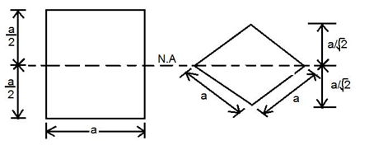 | L3 | CO2 | [7M]
8. |  | The principal stresses at a point in an elastic material are 250 N/mm²(tensile), 150 N/mm²(tensile) and 50 N/mm²(compressive). If the stress at the elastic limit in simple tension is 200 N/mm². Determine whether the failure of the material will occur according to the following  (i) Maximum principal stress theory  (ii) Maximum principal strain theory  (iii) Maximum shear stress theory  (iv) Maximum strain energy theory and Take µ=0.25 and E=200 KN/mm². | L4 | CO4 | [15M]

-- 00 -- 00 –

